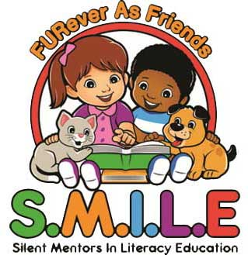

FURever As Friends is a non-profit 501c(3) organization of dedicated volunteers based in Gloucester County, N.J. who love giving back to the community with the help of our certified pets. The services that we provide enhance the bond between people and pets in a nurturing environment and are specifically designed to offer unconditional love and pet-assisted therapy to people of all ages in a variety of different settings.

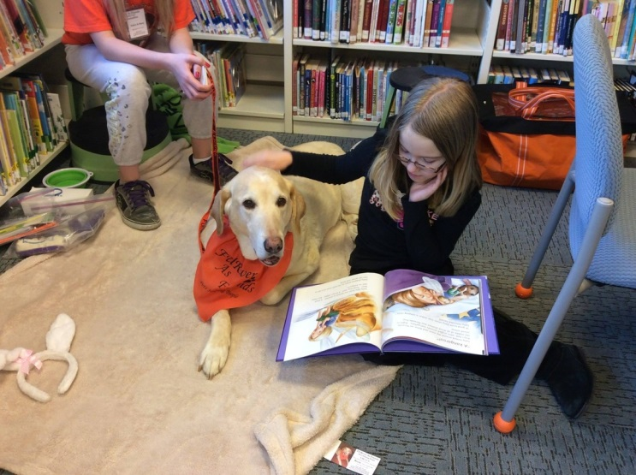
Programs coming to Wenonah Library in 2019
First & Third Mondays 6:30 – 7:30 PM

January 7 (one only) No August
February 4 (1 only) Sept 16 (1 only)
March 4 & 18 October 7 & 21
April 1 & 15 Howl-a-day party
May 6 & 20 November 4 & 18
June 3 & 17 December 2 & 16
July 8 & 22 Holiday Party

The goal of the S.M.I.L.E. program is to improve, encourage, and nurture the literacy skills of children with the help of certified pet therapy pets in library and school settings.

A child who has some reading difficulties or is hesitant to read aloud may find it more relaxing and less stressful reading to a pet than to a person because the pet doesn’t judge, criticize or correct the child’s reading. A pet can be a FURever Friend!

The S.M.I.L.E. Program is geared towards children who need to develop more confidence in reading. A team consisting of a handler and a pet (dog, cat, bunny), visit the contracted library or school twice monthly for approximately 60 minutes. Children typically spend 5-15 minutes one-on-one with the pet. Each reading session is dependent upon the child’s attention span and skills. Sometimes the session is extended if the child would like to read or talk to the pet for a little while longer and if the time constraints for the child, the adult in charge, and the handler will allow for extra time.

Purpose: To improve their literacy, inflection, communication, and vocabulary skills of children, while boosting their attention span and confidence.

Environment: A quiet room with the child, the therapy pet, and the handler. This encourages focus since there is little noise and distraction during the sessions.

Time: 5 to 15 minutes per child for a reading session. The maximum amount of children is usually around 5 to 8 per session to ensure that the session does not overextend the therapy pet’s capabilities.

Contact Wenonah Library 468-6323 or wenonahlibrary@hotmail.com or www.fureverasfriends.org for more information.

